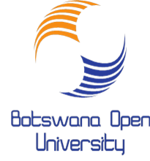
Library Instruction Sessions Available for School of Education Learners
Sessions are conducted predominately virtually and when the need arises in our Library Instruction room (conference room). Only 10 customers will be allowed per session. Please contact the Librarian either by phone or e-mail to book a slot at: 6865621 ext.205/3009, e-mail: tmotubudi@staff.bou.ac.bw
Integrated Lesson Planner
Time slots  1st -5th February 2021 | Type of Session | Topics | Target group | Average session length
Monday-9:00hrs-12:00hrs  AND  Tuesday-900hrs-12:00hrs | One-time Instruction:  1st -5th Feb 2021 | -Specific research assignment  -Specific strategies for searching particular databases | Learners doing research | 1h. 30 minutes
Wednesday-9:00hrs-12:00hrs  AND  Thursday-9:00hrs-12:00hrs | Multiple Instruction Sessions:  8th-19th Feb 2021 | -Understanding of disciplinary research strategies, as well as more detailed instruction on complex searching techniques. | Continuing Learners | 1h.30 mins
Friday-9:00hrs-12:00hrs | Individual Consultations: 1st-26th Feb 2021 | -Students to meet individually with Librarian during the process of completing an assignment.  -How to meet the specific needs of students with varying degrees of information fluency. | Continuing Learners | 1h.30 mins

-E-mail: tmotubudi@staff.bou.ac.bw

